TTE CORRECTIONS
* In the FAQ section, all the content appears too close together — add proper spacing.
* add STATISTICS in admin>settings for front Why work with us section in all over site
* add user type in admin>trainers
- Staff
- Trainer
Label = Staff & Trainers in side menu
And show both users in Meet the team section on about page
* add Category dropdown in testimonial
- Course (for course specific)
- Trainers (Meet the team section on About page)
- General

Course (for course specific)
Admin>Edit Events> add Testimonials section and user can select the course category testimonial and show the testimonials in front course details page

* In About Us > Meet the Team, add a "Testimonial (Trainer Category)" section after the 4 trainer/staff member.
* In Admin > Event Categories > Add Category, change the label and placeholder description to "Card Label".
* Show the "Card Label" field in Book a Course > Cards > Event Category.
* On the Home > Testimonials section, show only General category testimonials.
* On the Home > Why Us section, also show only General category testimonials.
* Add a new "Consultancy Projects" category in the Add/Edit Testimonial Category section, and display testimonials from this category on the Consultancy & Projects page.
* Use Sentence case (capitalize only the first letter of each sentence or title) throughout the entire site — both frontend and admin.
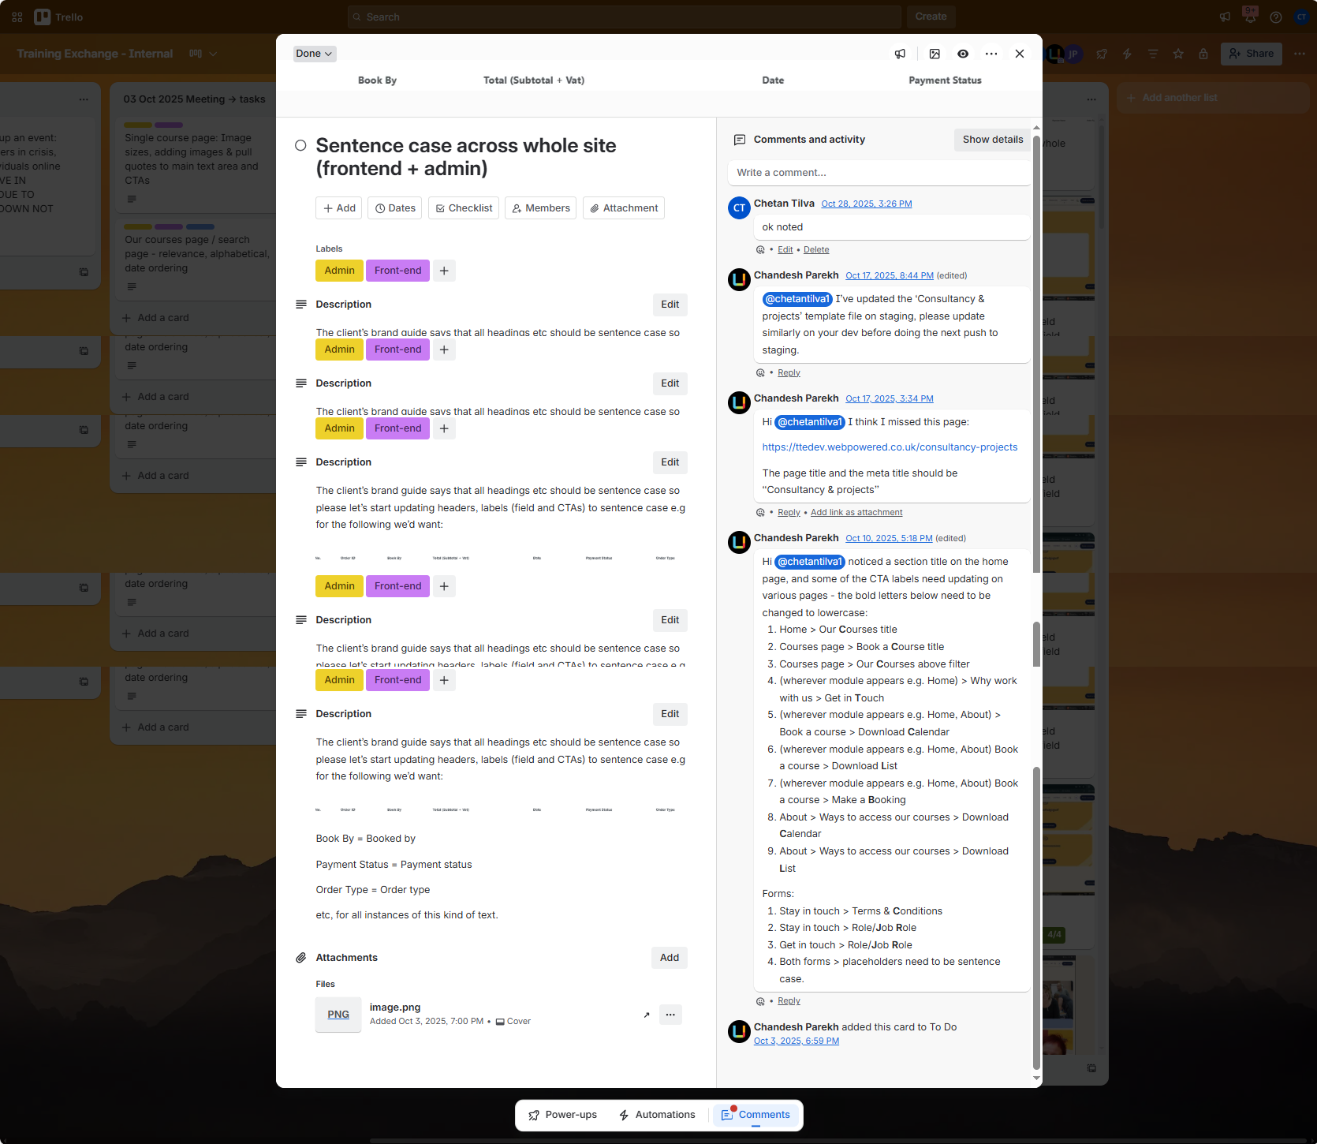

- Forms > Organisation field needs to be a free text field
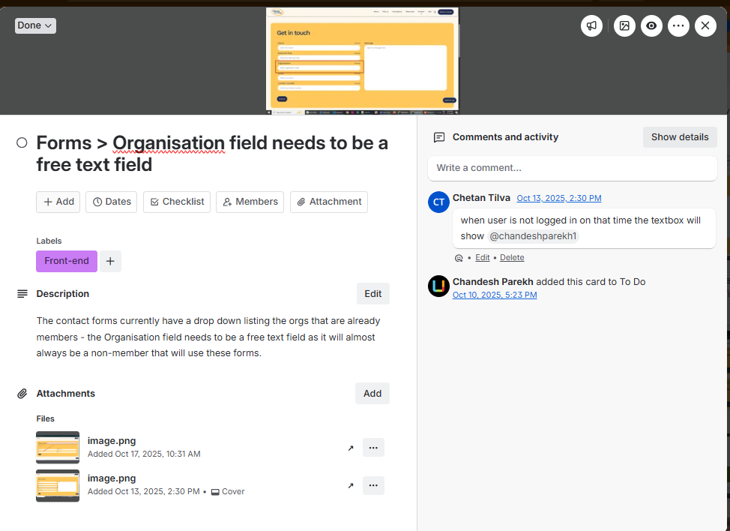

News & resources page
'News & resources' - note it should be lowercase 'r' in title for 'resources'
Pagination after 12 posts
Colour coding of cards based on category - see Figma design
Posts are opening in a new tab when triggered from this page - they should open in the same page

Single news item page

'Download PDF' cta missing see figma design

'Similar content' - this should show other content with the same tag and should not show the current post

Add 'Morea articles' link below 'Similar content' section - see Figma design

Admin>Event categories: can we make them so the client can re-order them?

Admin>Inspire motivates: can we make them so the client can re-order them?

Front>book a course>trainer dropdown 'Trainers' dropdown to be alphabetical

Admin>Course/event editor - update labels for tickets section
Update the labels for the tickets section:
Change:
- Tickets Limit : → Limit tickets for orgs?
- Number of Tickets Limit: → Max tickets per org

